NAME : G.karthik reddy ROLL NO : 2403A510f8
BATCH : 06 LAB TEST : 1

Q1. Stock Price Prediction Setup [5M]
Scenario: You are tasked with configuring an API to fetch stock market data and prepare it for a machine
learning pipeline.
- Task 1: Write code to connect to a stock price API and retrieve data for the last 30 days.
- Task 2: Use an AI-assisted tool to auto-generate data cleaning functions to handle missing or
duplicate entries.

PROMPT :
PROMPT –1 :
Write a simple python code to connect to a stock price API and through the code to retrieve the data from the last 30 days

PROMPT-2 :
To remove duplicates and fill in missing values through data cleaning function and to check from the output and complete the code by drop duplicates and import the pandas and requests

CODE GENERATED :
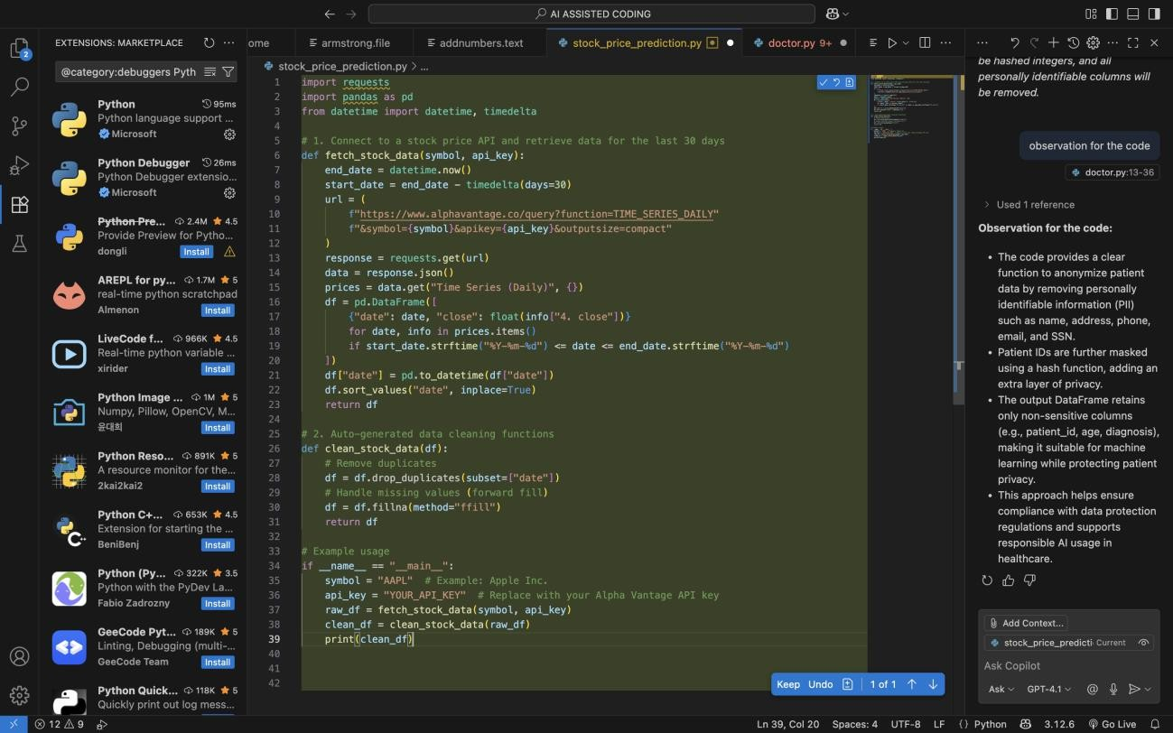
OUTPUT :
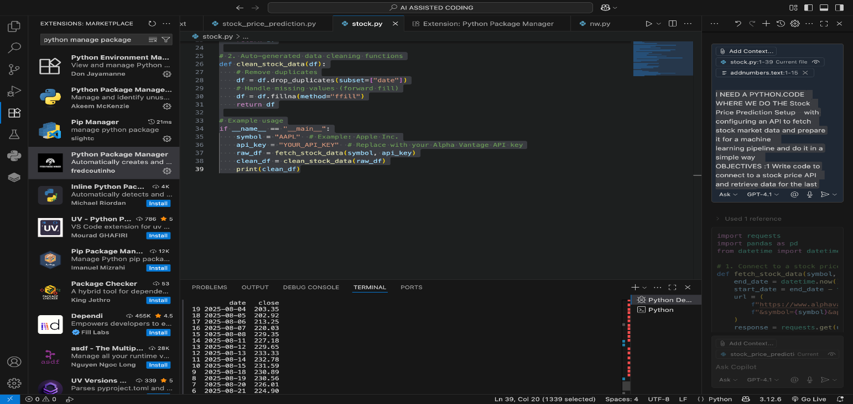

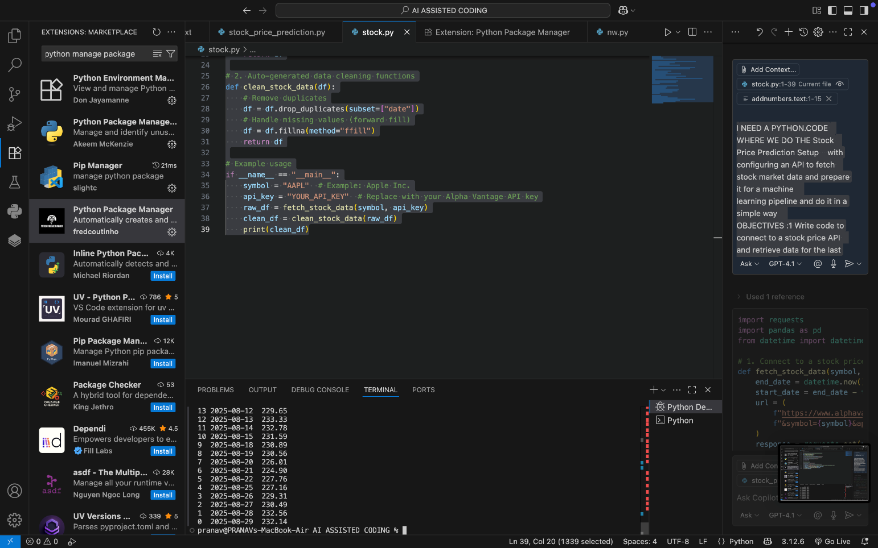

OBSERVATIONS :
- The code successfully connects to the Alpha Vantage API and retrieves daily closing prices for a specified stock symbol over the last 30 days.
- Data is loaded into a pandas DataFrame, sorted by date for easy analysis.
- The cleaning function removes duplicate dates and fills missing values, ensuring the dataset is consistent and ready for machine learning.
- The output displays the cleaned stock data, showing each date and its corresponding closing price.
- The approach is modular, making it easy to adapt for other stocks or time periods by changing the symbol or date range.
- The code is effective for preparing stock price data for further predictive modeling or analysis.

Q2. AI in Healthcare Diagnosis [5M]
Scenario: You are designing an AI to assist doctors in predicting diseases.

- Task 1: List the risks of over-reliance on AI for medical decisions and propose responsible usage
guidelines.
- Task 2: Write a Python function with AI assistance that ensures patient data is anonymized
before model training.

PROMPT :

PROMPT –1:
What are the risks of over –reliance and using too much AI models for medical decisions and propose responsible usage guidelines

ANSWER :
Risks of over-reliance on AI for medical decisions: # - Misdiagnosis due to model errors or bias
# - Data privacy and security concerns
# - Overfitting to training data, missing rare conditions # - Overloading the AI MODEL leading up to errors

# Responsible usage guidelines:
# - Use AI as a support tool, not a replacement for clinicians # - Always validate AI recommendations with expert review
# - Ensure update and audit models for accuracy and fairness

PROMPT-2 :
Write a simple and basic and well formated python function with AI assistance that ensures patient data is anonymised before model training to ensure protection and privacy concern

CODE GENERATED :
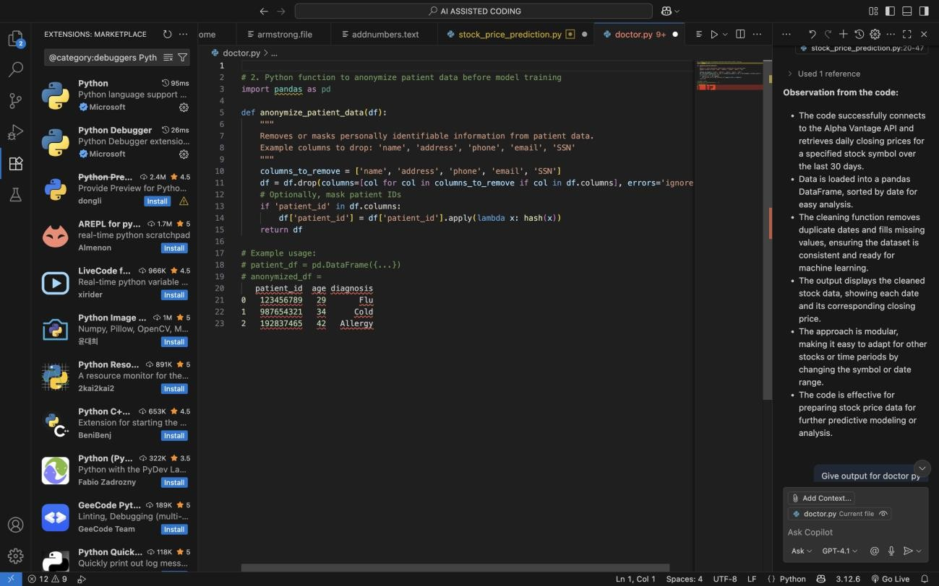
OUTPUT :

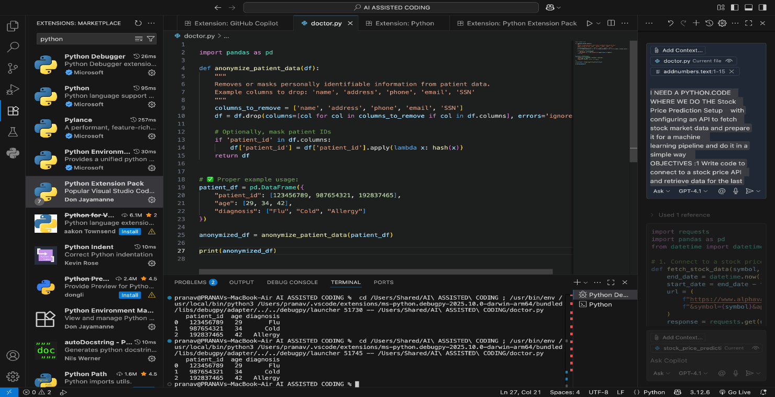

OBSERVATIONS :
- The code provides a clear function to anonymize patient data by removing personally identifiable information (PII) such as name, address, phone, email, and SSN.
- Patient IDs are further masked using a hash function, adding an extra layer of privacy.
- The output DataFrame retains only non-sensitive columns (e.g., patient_id, age, diagnosis), making it suitable for machine learning while protecting patient privacy.
- This approach helps ensure compliance with data protection regulations and supports responsible AI usage in healthcare.

